1 Create numeric, character, and logical vectors and display type and content.

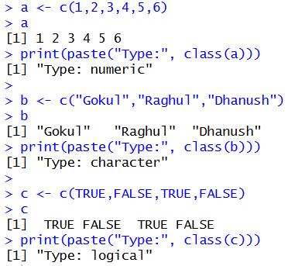

2. Create labeled matrices (5×4, 3×3, 2×2) filled by row/column.

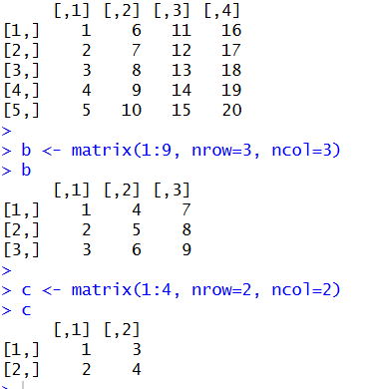

3. Write an R program to create and display a 3D array with specified rows,columns, and tables.

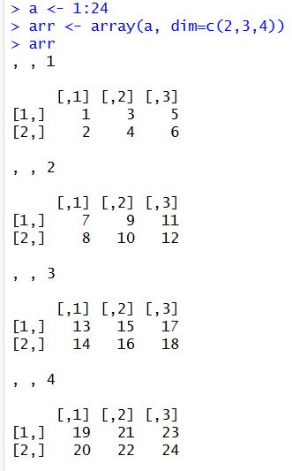

4. Create arrays from vectors with dimension names, print specific elements.
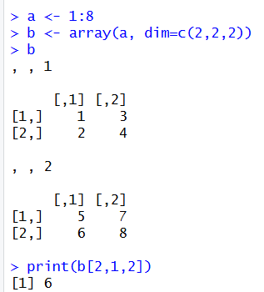

5. Create and manipulate factor variables (e.g., women’s dataset heights, random
LETTERS sample).
